**Practical No. 6**

1. **Using Packet Tracer, create a network with three routers with BGP and each router associated network will have minimum three PC. Show Connectivity.**

**Step 1: Take 9 PCs**

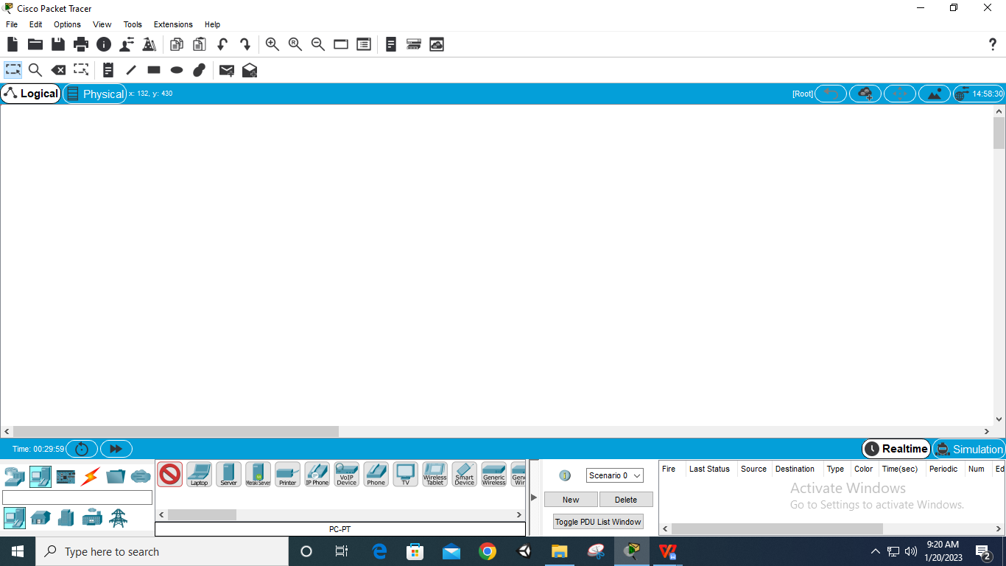

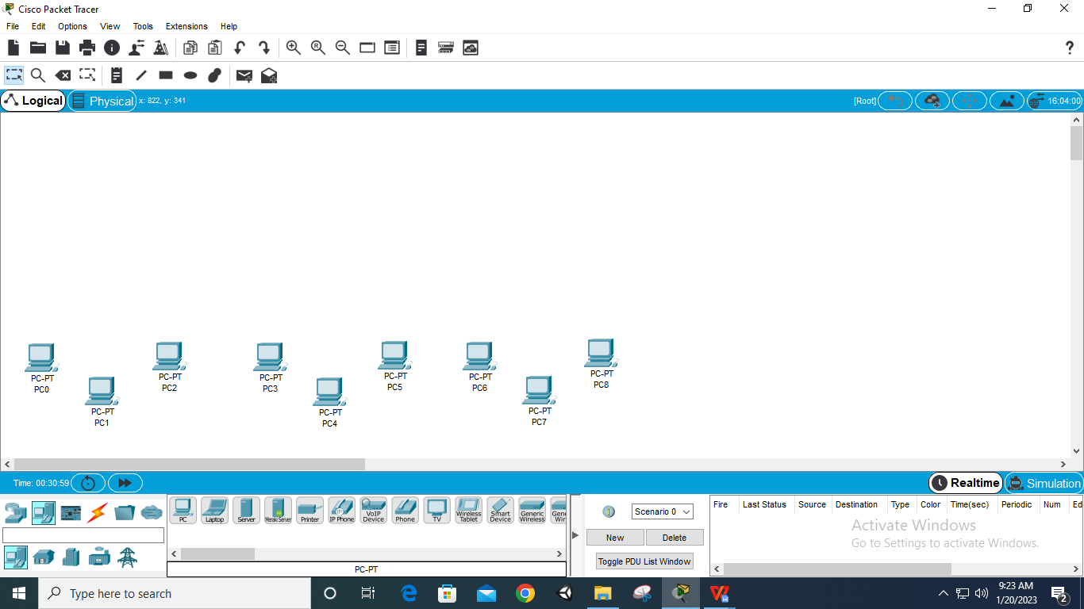

**Step 2: Take 3 Switches of name 2890-24**

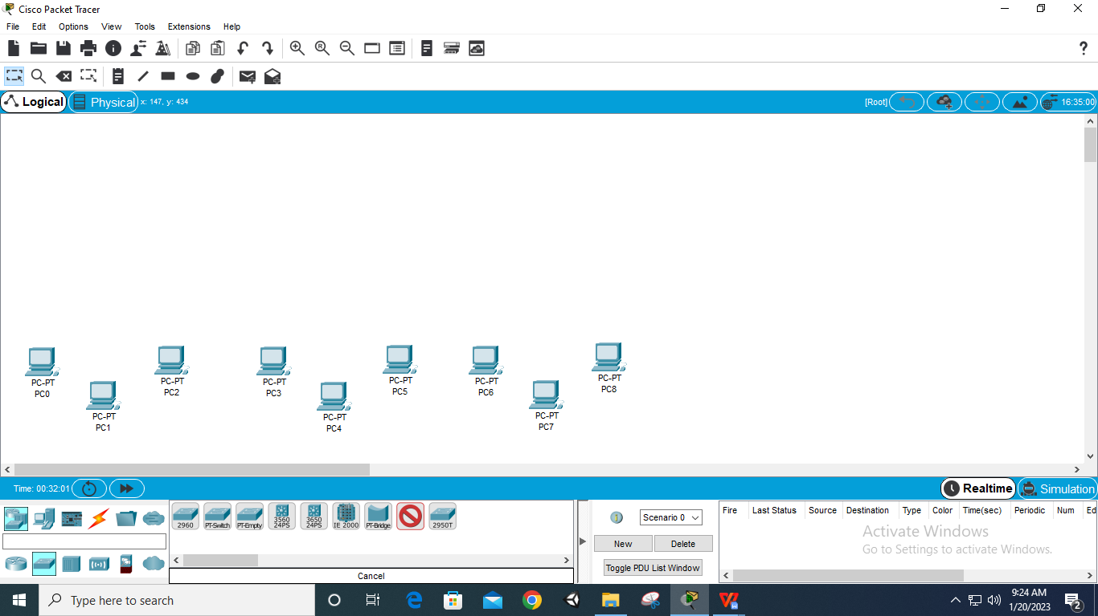

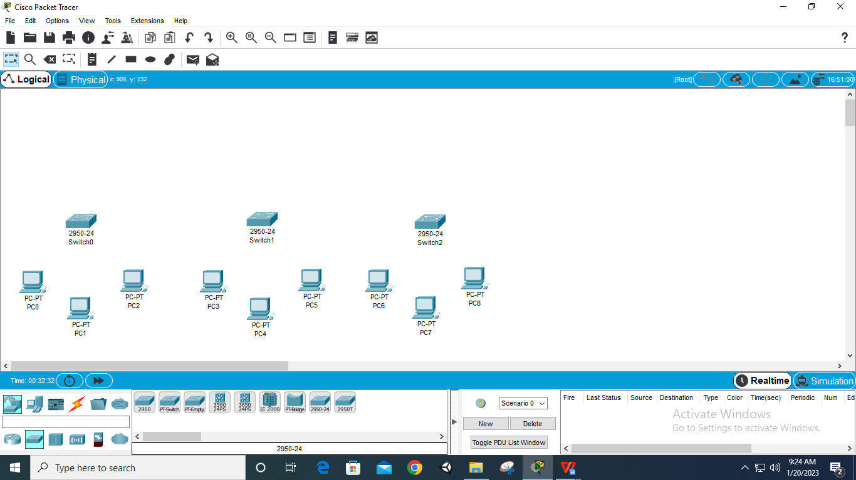

**Step 3: Take 3 routers of name 1841**

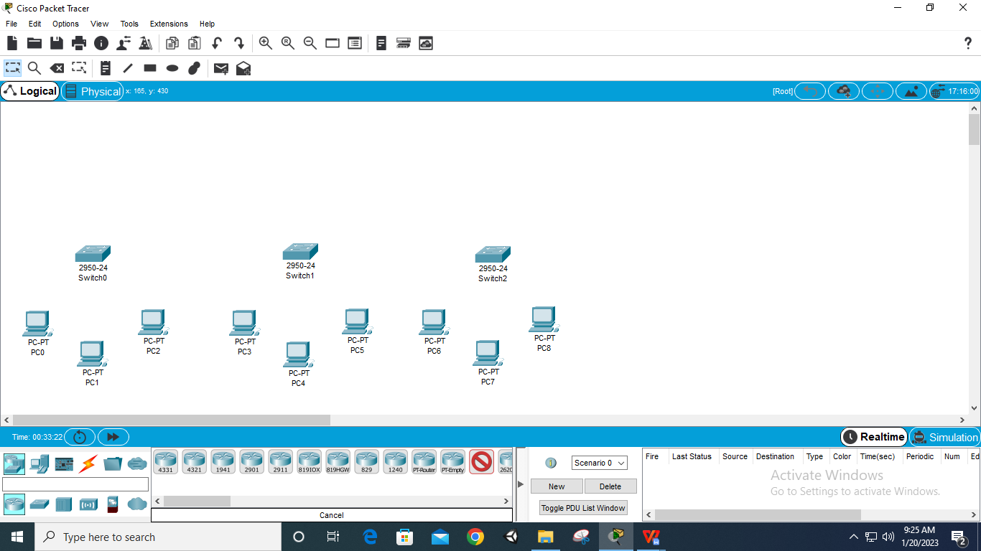

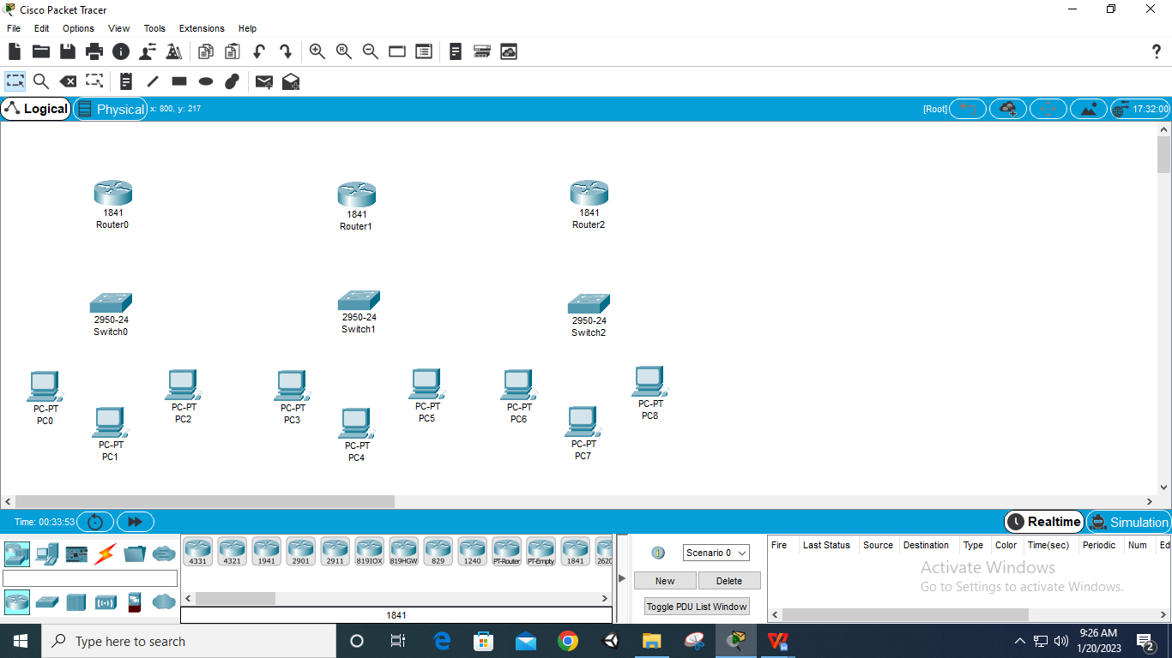

**Step 4: Connect all PCs to their respected Switch via ‘Automatically Choose Connection Type’**

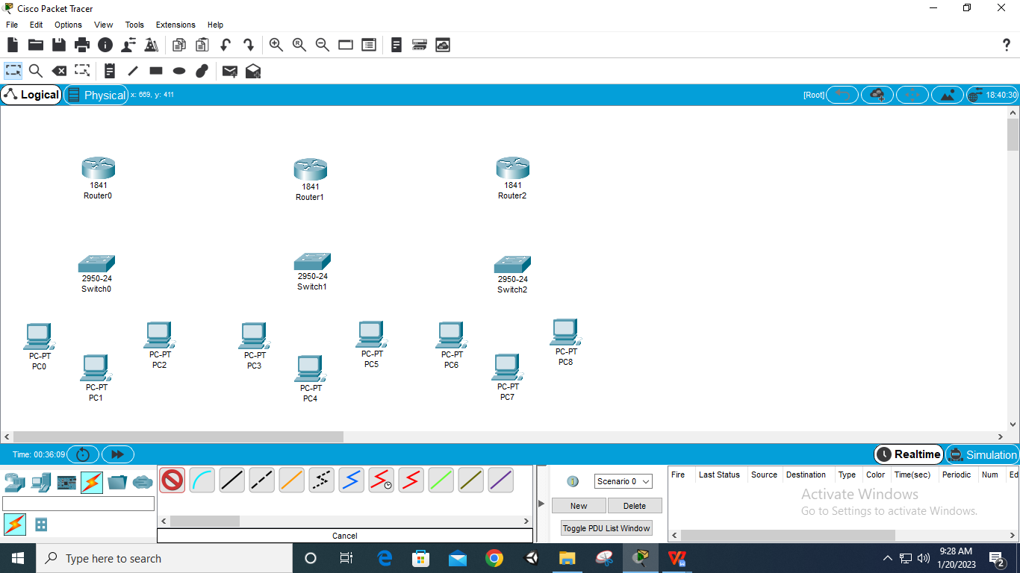

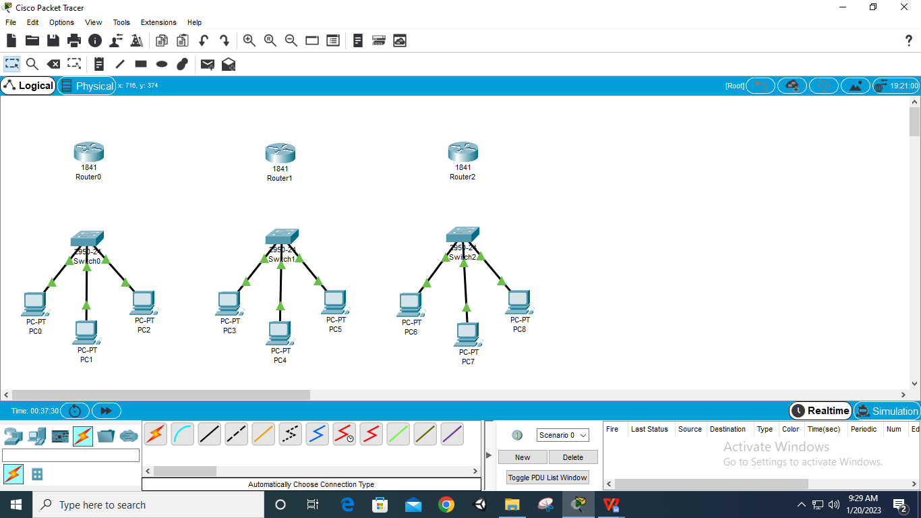

**Step 5: Connect all Routers to their respected Switch via ‘Automatically Choose Connection Type’**

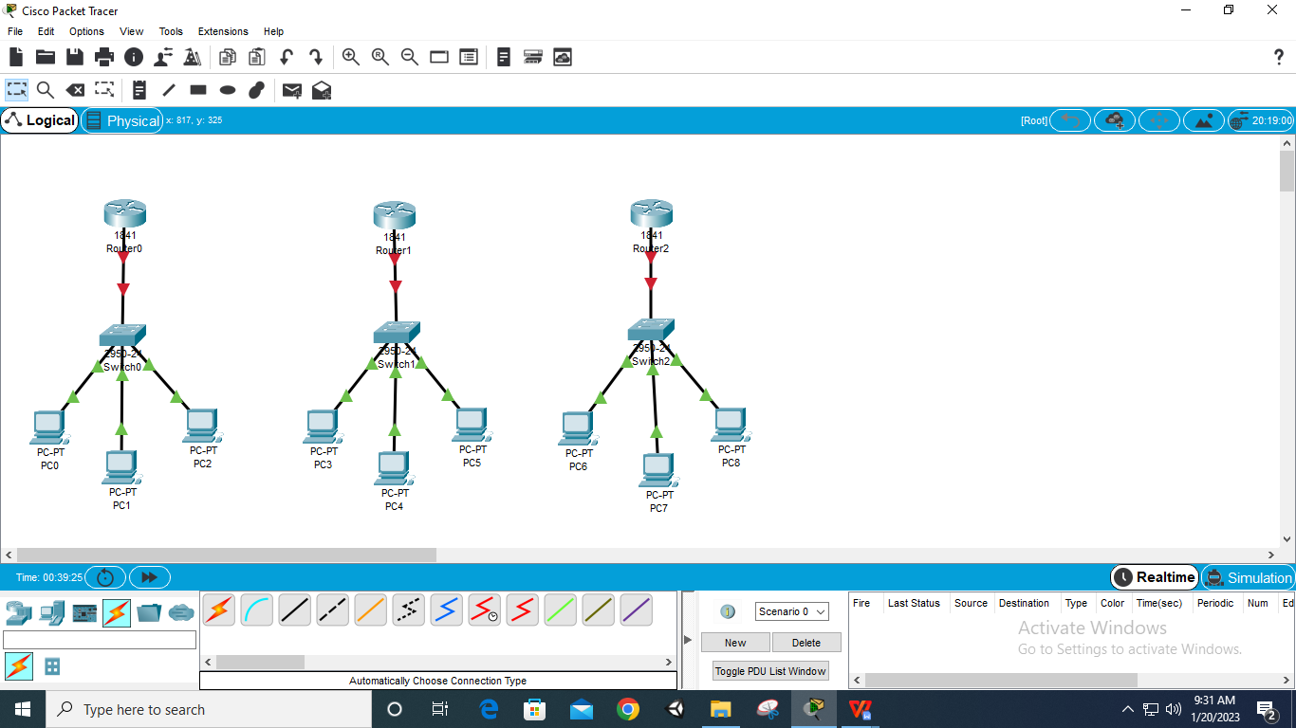

**Step 6: Select Router – Physical – WIC 2T – off Router – add Port – on Router (for all 3 Routers)**

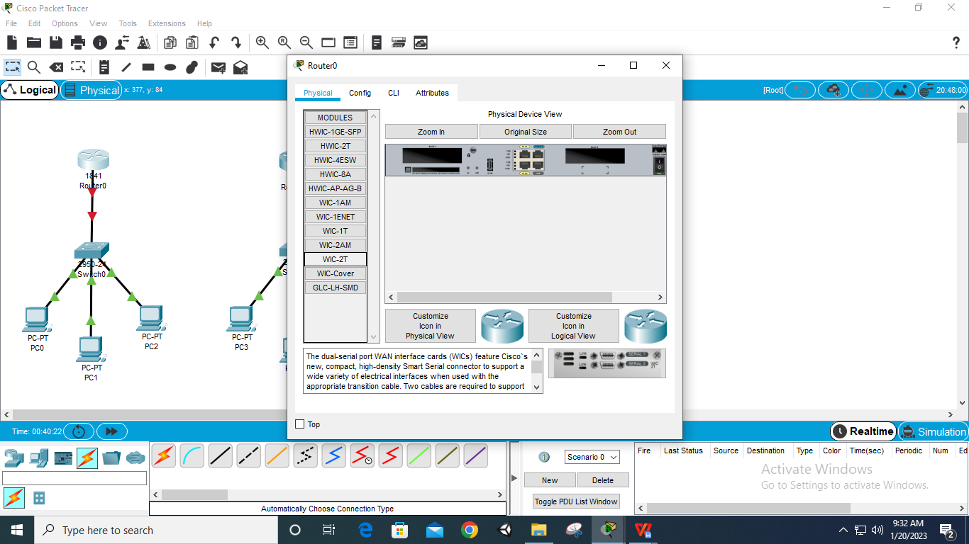

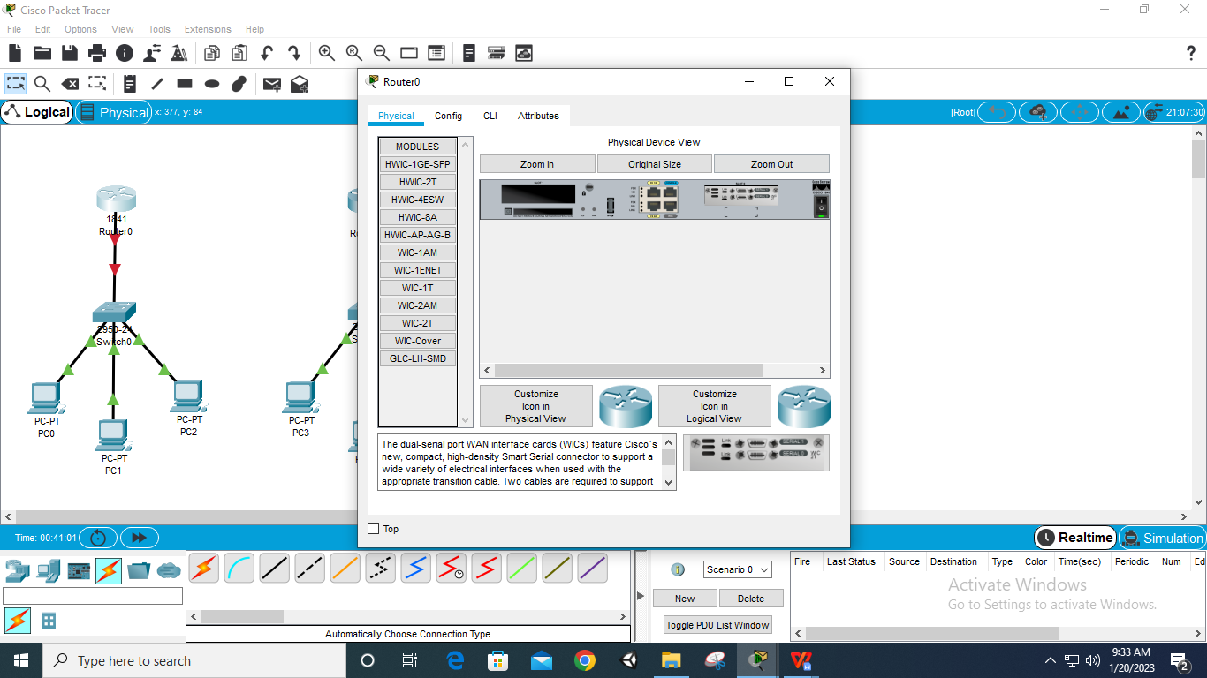

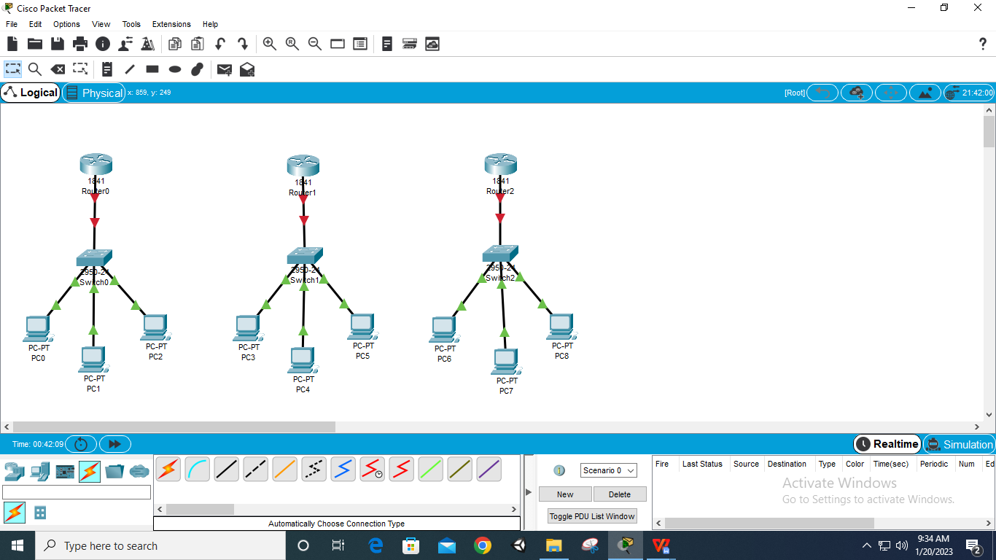

**Step 7: Connect Routers via ‘Automatically Choose Connection Type’**

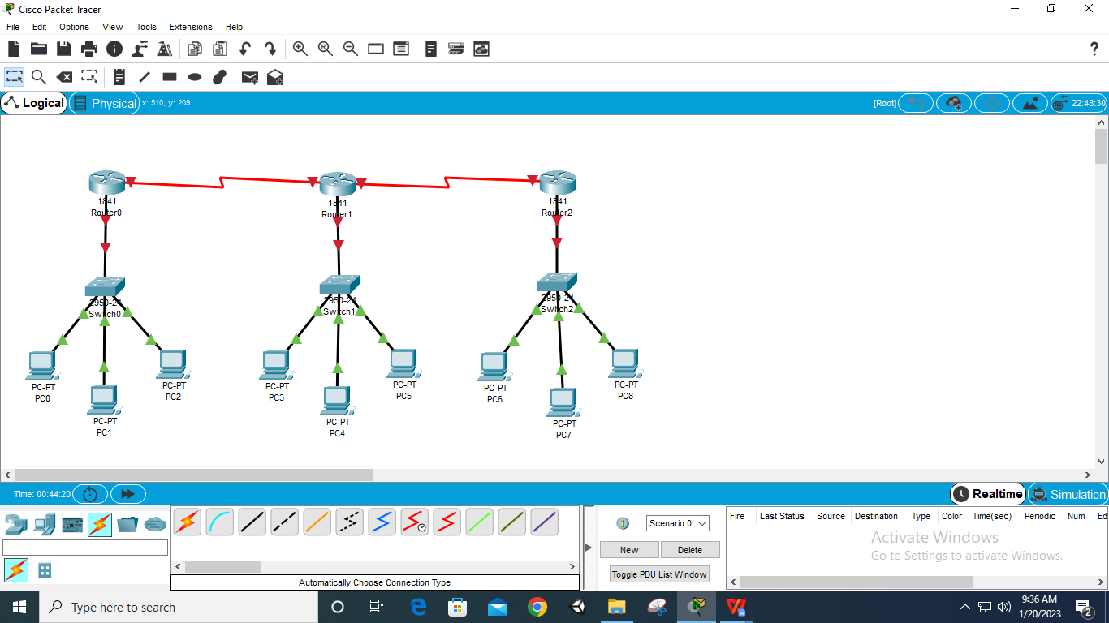

**Step 8: Select Router – Config – Fastethernet 0/0 – give IP as – 10/20/30.0.0.1 – Port Status on (for all 3 Routers)**

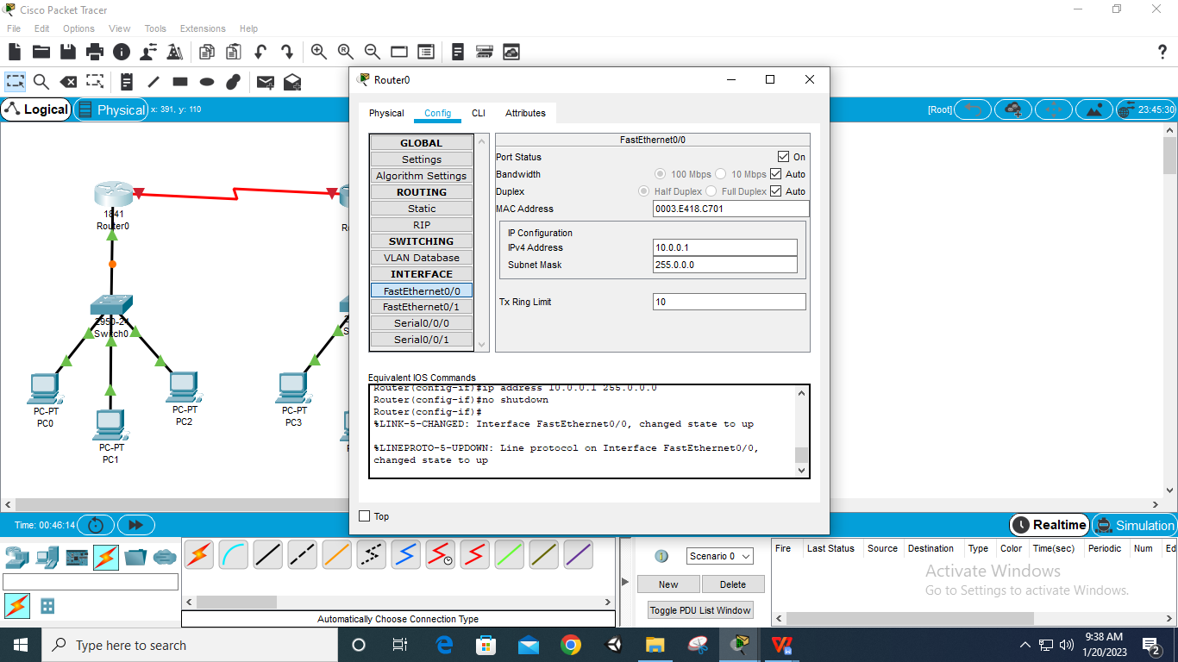

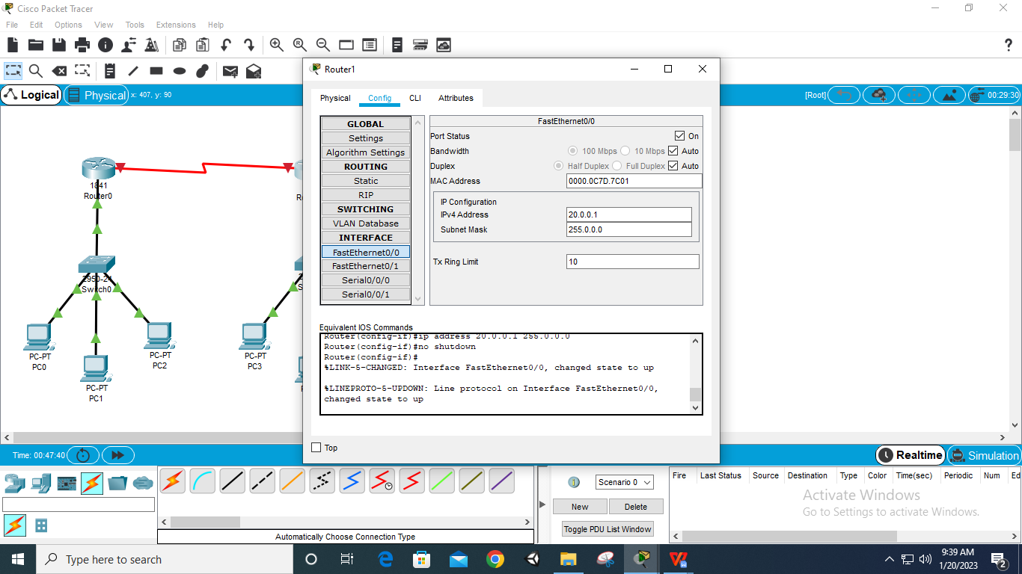

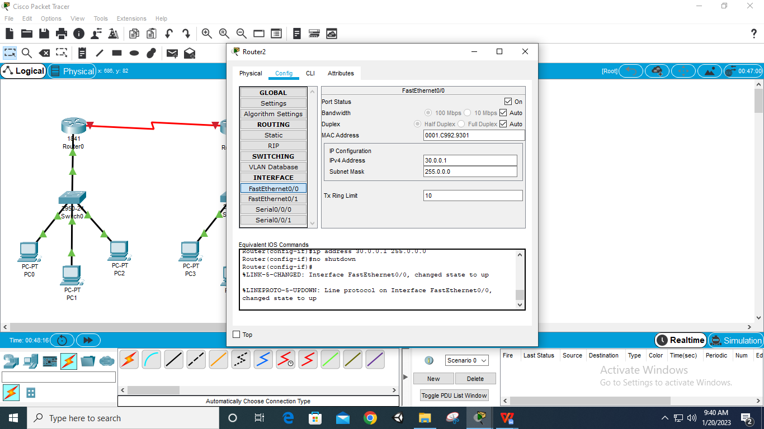

**Step 9: Select PC – Desktop- IP Configuration – IP – 10/20/30.0.0.2/.3/.4 & Default Gateway – 10.0.0.1/2/3(Router IP) (for all 9 PCs according to their Routers)**

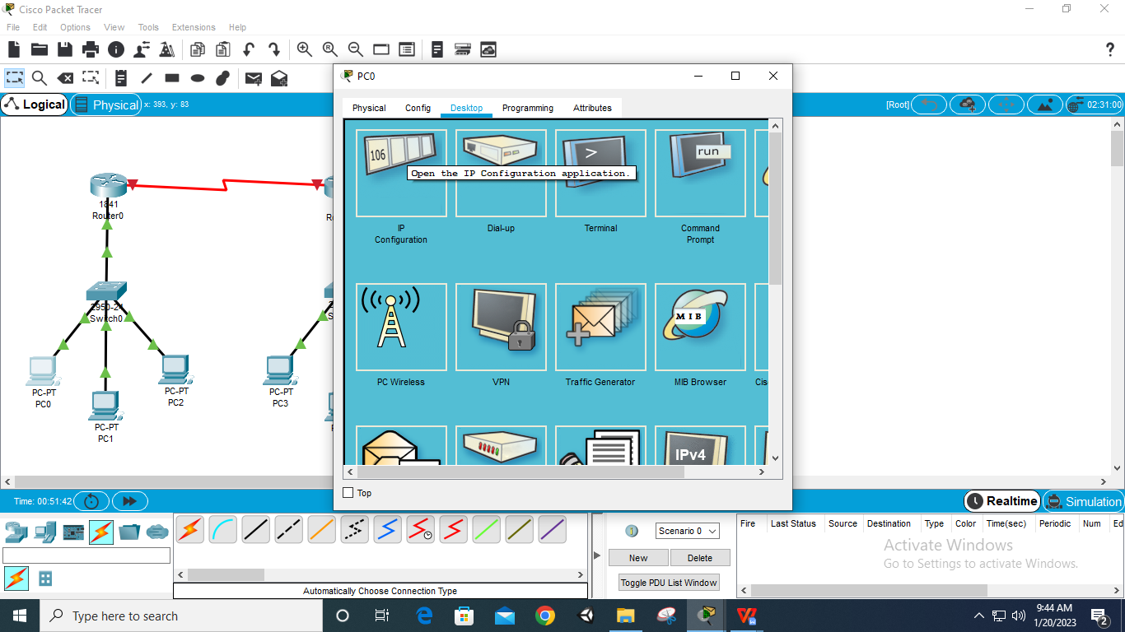

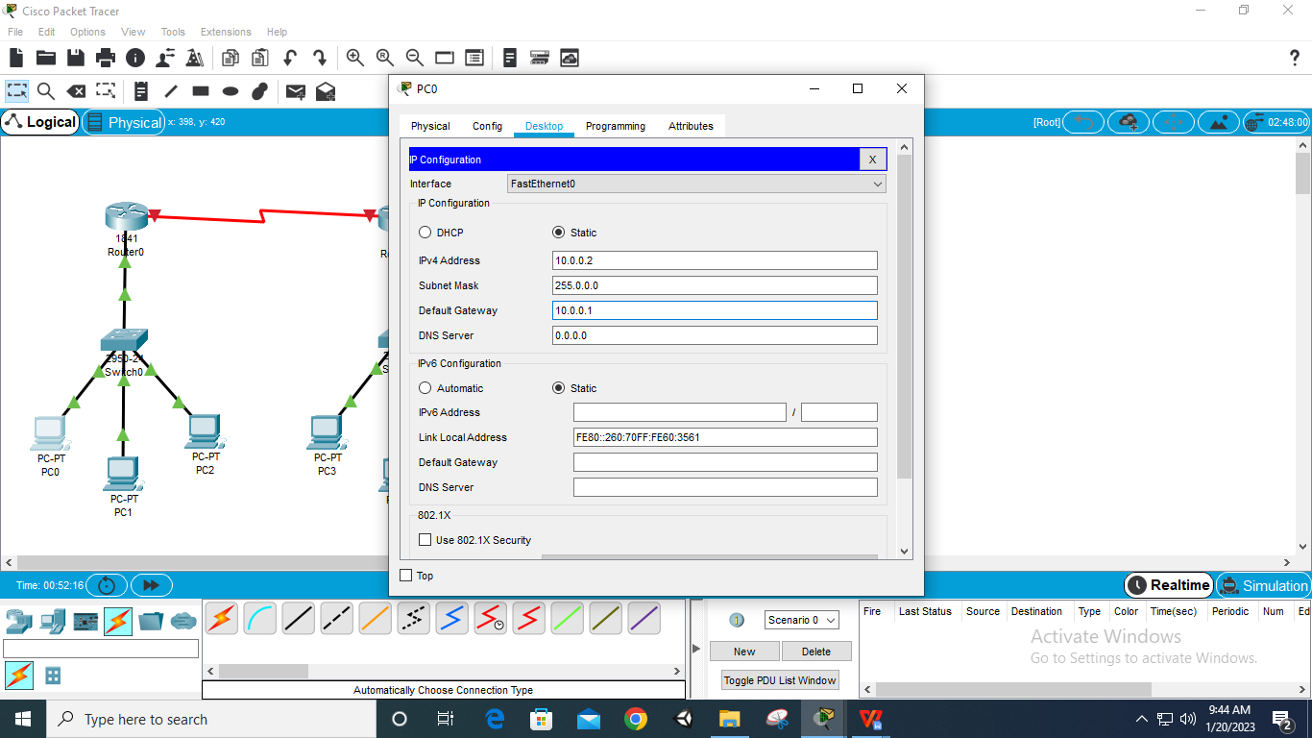

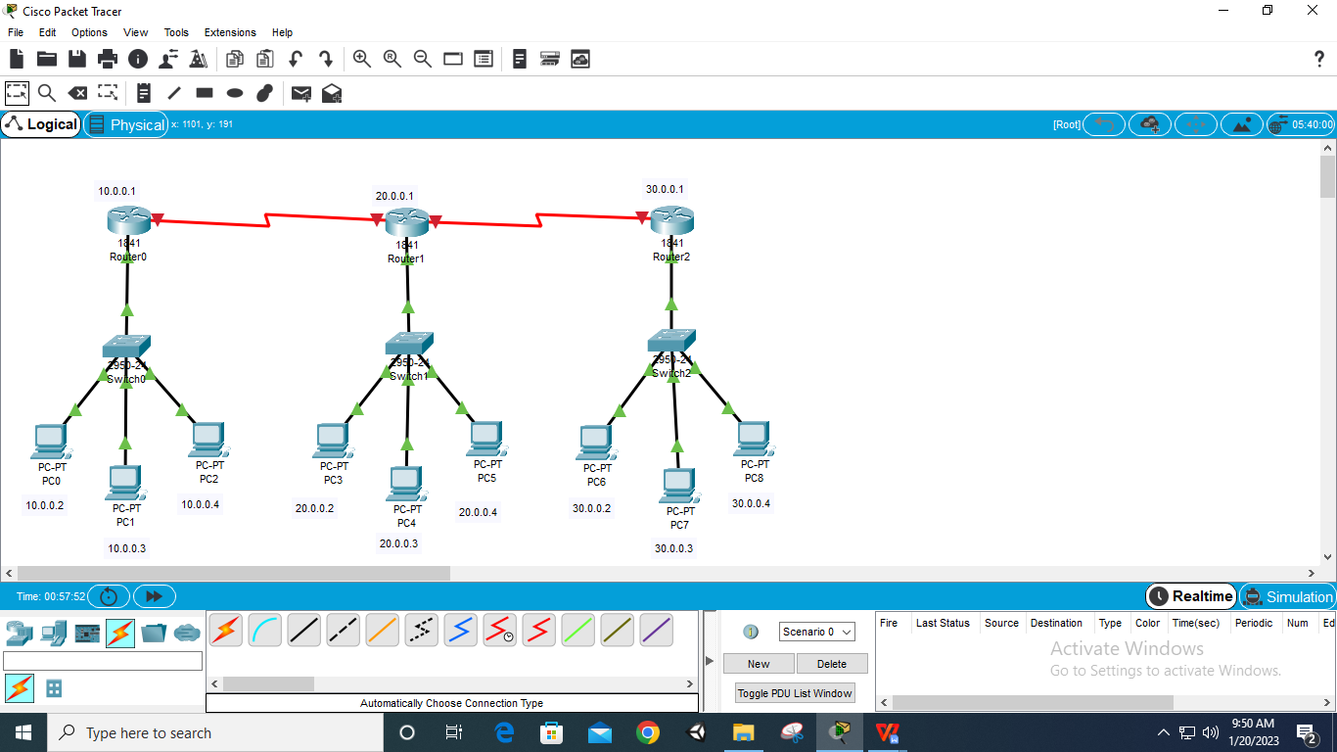

**Step 10: Select first Router – Config – Serial 0/0/0 – set IP – 40.0.0.1 – on the Port**

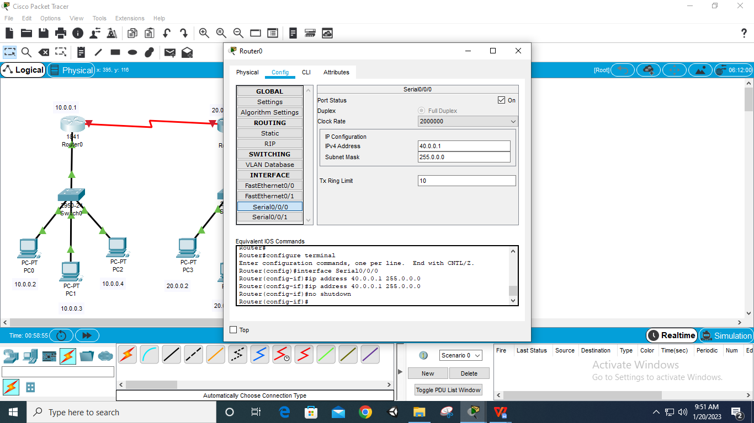

**Step 11: Select second Router – Config – Serial 0 0/0 – set IP – 40.0.0.2 – on the Port**

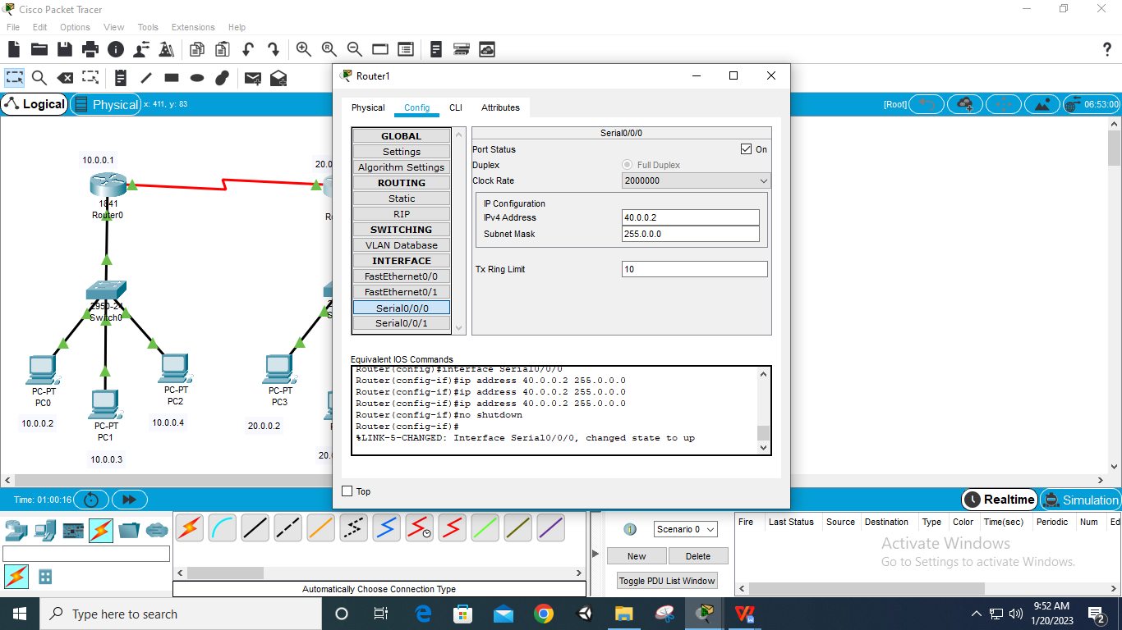

**Step 12: Select second Router – Config – Serial 0/0/1 – set IP – 50.0.0.1 – on the Port**

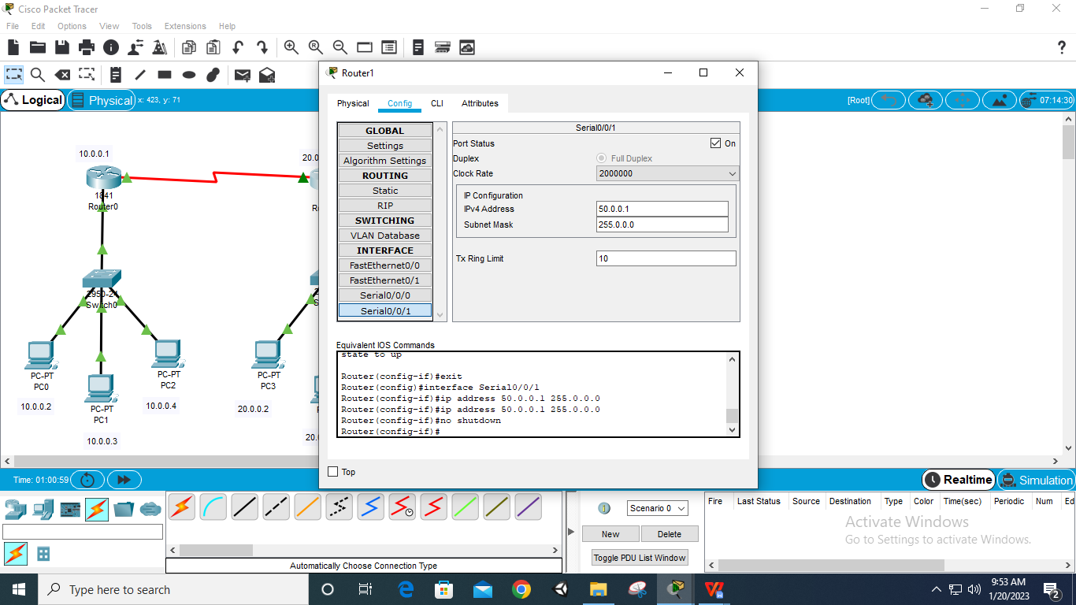

**Step 13: Select third Router – Config – Serial 0/0/0 – set IP – 50.0.0.2 – on the Port**

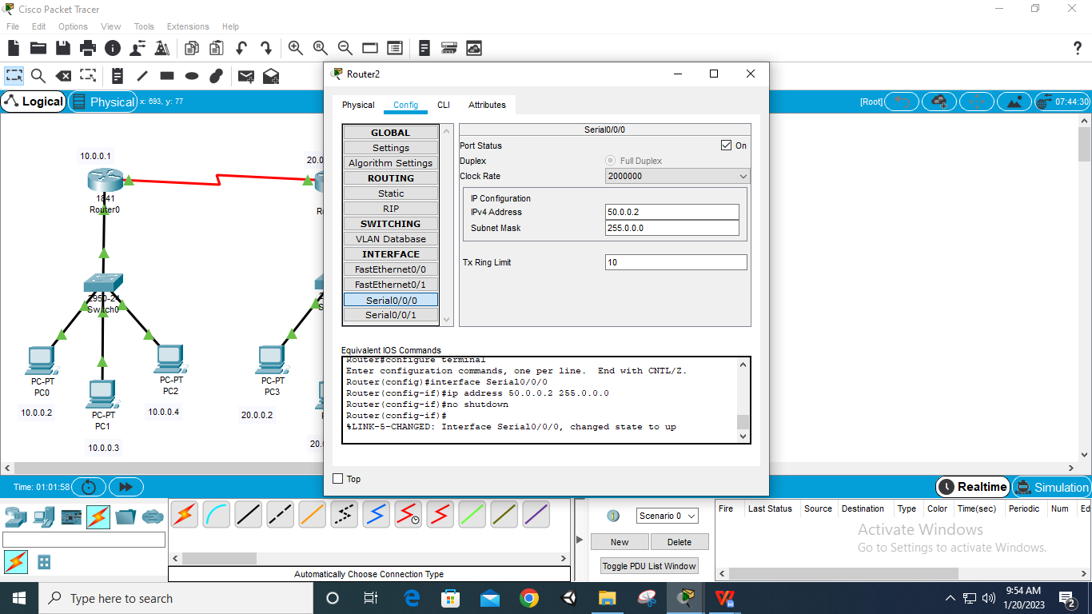

**Step 14: Select first router – config – RIP – Network – add 10.0.0.0, add 40.0.0.0**

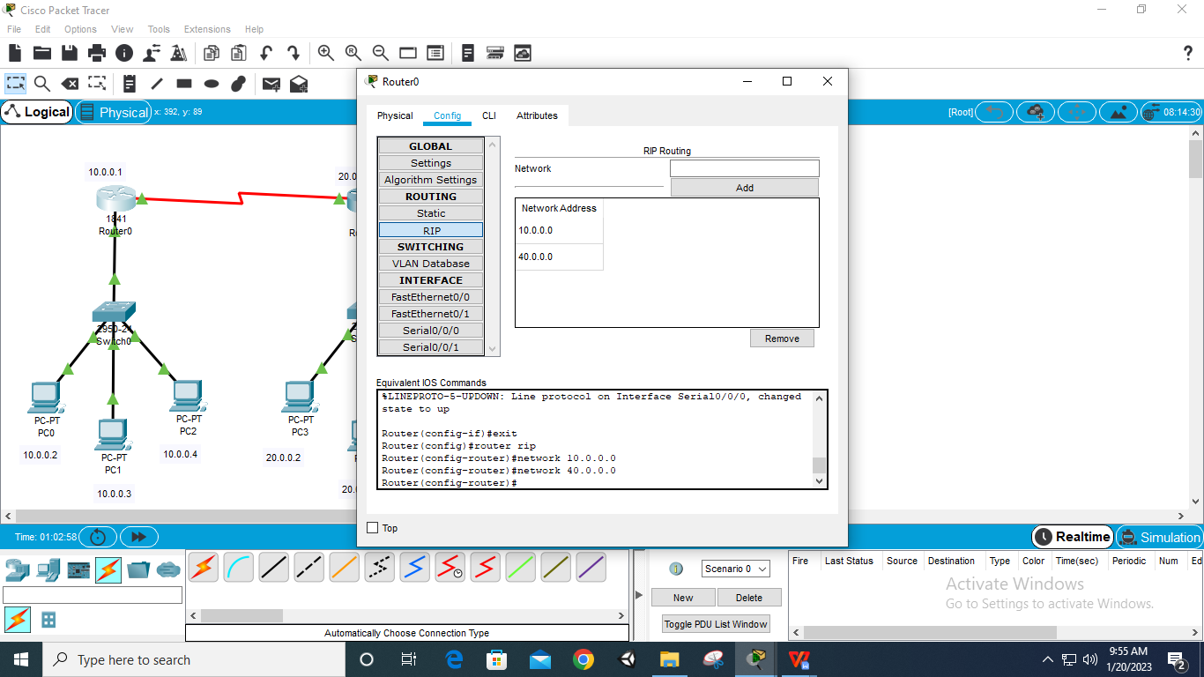

**Step 15: Select first router – config – RIP – Network – add 20.0.0.0, add 40.0.0.0 and add 50.0.0.0**

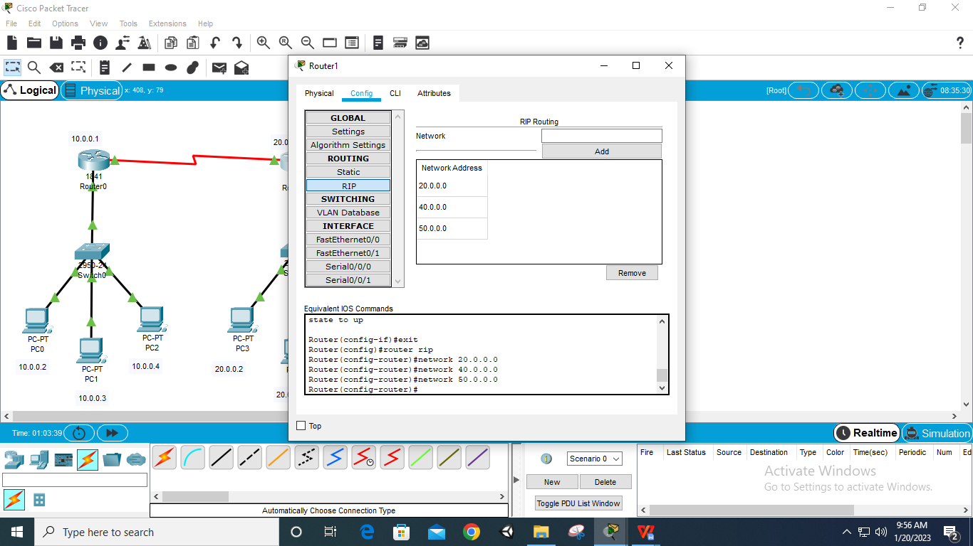

**Step 16: Select first router – config – RIP – Network – add 30.0.0.0, add 50.0.0.0**

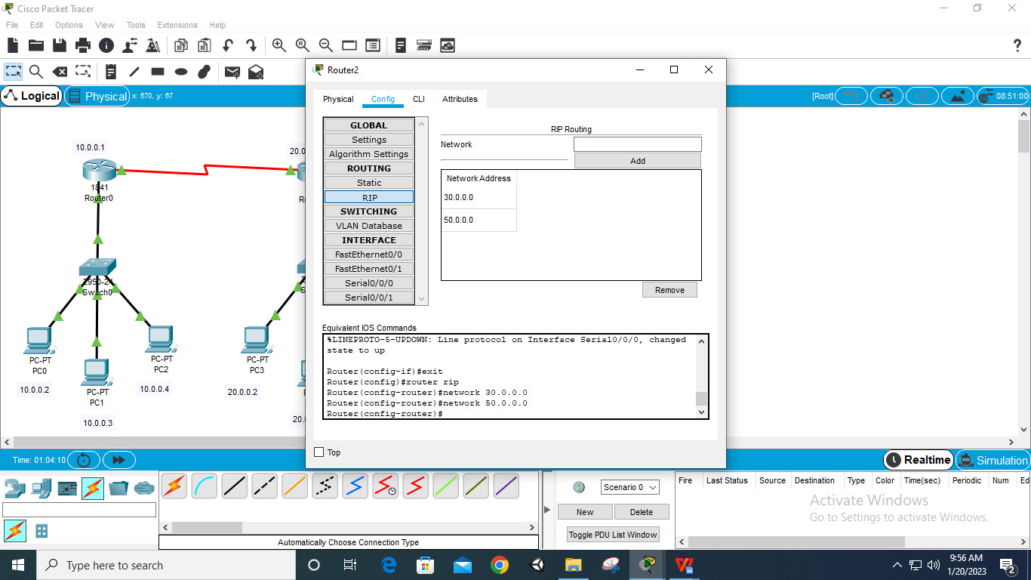

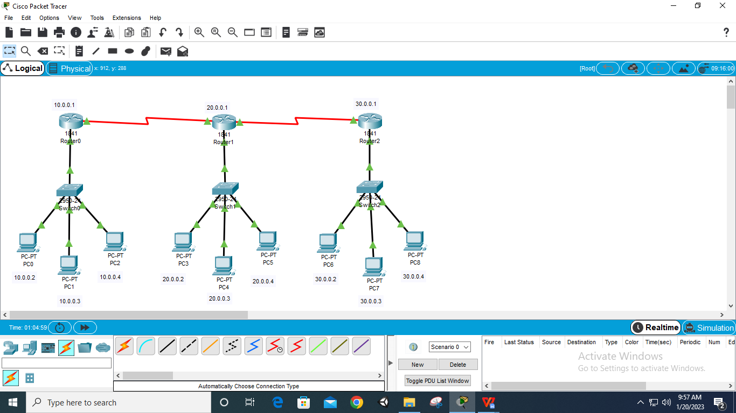

**Step 17: Add Packets and Run Simulation**

